## Lesson 3 – Activity Sheet

## Getting Started

## Different sensors can be used to represent different senses of humans and animals

## **Light sensors** can work like our eyes detecting brightness and darkness

* **Line sensors** can work like a sniffer dog following a trial
* **Ultrasonic** detectors work just like bats, by sounding out an ultrasonic sound wave out as a ping and waiting to see how long it takes for the sound wave to reflect off a solid object and be echoed back. This time can then be converted into distance

## Success Criteria

* Use code to take a reading from an ultrasonic sensor to gauge distance
* Use code to take an **analogue** reading from a light sensor
* Use code to detect the presence of a line or marker as part of a line follower

## Pro-tip

When using the ultrasonic sensor make sure you set the units – metric (cm) or imperial (inches). Why would you measure the unit in time? How would using the sensor under water affect the distance measured?

## Test Time

**Ultrasonic Detector**

* Install the sonar extension.

* What happens when you use the ultrasonic detector with hard and soft objects?
* Does a shiny surface make a difference?

## 

**Light Sensor**

* What is the lowest reading you can get in your classroom?
* What happens if you lower the lights?
* How bright/close does the light need to be to give a maximum reading?

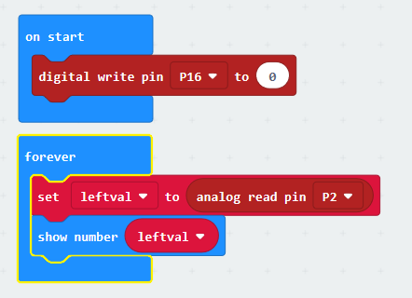

**Line Follower**

* How close does the line need to be?
* What happens if you use different colours for the line?
* What happens if you change the thickness of the line?

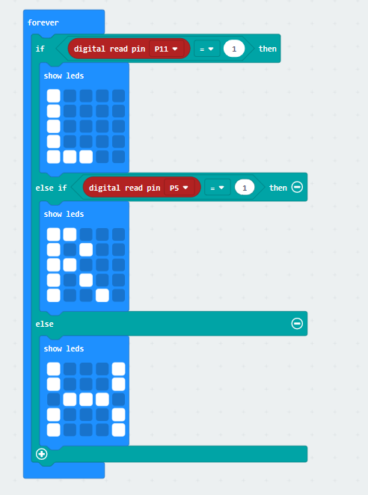

## Stretch Tasks

* Measure how accurate the ultrasonic distance measure is
* What materials reflect the sound best? (brick, plaster, wood, hard soft etc) Try to explain why.
* Is the sound sensor affected by outside noise sources?
* Identify the thinnest line the line sensor will detect (in cm)

Document your results

## Final Thoughts

In this lesson we looked at inputs, especially sensors, we looked at how these compare to animal senses.

We demonstrated how we can read from three different sensors and interpret or display the result from the sensor.

You should now consider what the limitations of these sensors are and how we could combine different sensors together to try and negate these limitations.